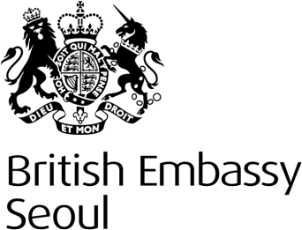
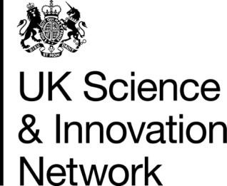

Korea – UK Workshop on Tidal Energy Collaboration
Monday 9 and Tuesday 10 March 2015, Aston Hall, British Embassy Seoul

Day One – Monday 9 March

Time | Scoping Opportunities for Research Collaboration
10:00 – 10:30 | Registration  Coffee on Arrival
10:30 – 10:40 | Welcome and Introduction  UK Embassy/ SIN
10:40 – 10:55 | New & Renewable Energy in Korea- Policy and Industry  Hyungkee Yoon, President of Korean Society for New and Renewable Energy, Korea
10:55 – 11:15 | UK National Tidal Energy Research Program  Cameron Johnstone, Director, ESRU, University of Strathclyde, UK
11:15 – 11:40 | Coffee and Networking Break
11:40 – 12:05 | Tidal energy research activities in Korea  Chul Hee Jo, Professor, Inha University, Korea
12:05 – 12:30 | Tidal energy research at the University of Southampton  AbuBakr Bahaj, Professor of Sustainable Energy, University of Southampton, UK
12:30 – 14:00 | Lunch
14:00 – 14:25 | Marine renewable research at the Korean Maritime and Ocean University  Young Ho Lee, Professor, Korea Maritime and Ocean University, Korea
14:25 – 14:50 | Tidal energy research at the University of Cardiff  Tim O’Doherty, Professor of Fluid Mechanics, University of Cardiff, UK
14:50 – 15:15 | Physical & geological marine environmental issues on Sihwa lake tidal power plant implementation  Seung Buhm Woo, Professor, Inha University, Korea
15:15 – 15:40 | Tidal Energy Research at the University of Strathclyde  Cameron Johnstone, Director, ESRU, University of Strathclyde
15:40 – 16:10 | Coffee and Networking Break
16:10 – 16:20 | Accelerating the transfer of new knowledge from research output to industrial uptake.  Gareth Davies, UK Science and Innovation Network
16:20 – 17:20 | Panel Discussion: UK- Korea Opportunities and mechanisms to stimulate collaborative research  Chair Prof. AbuBakr Bahaj & Prof. Chul Hee Jo
 | End of Day One
18:00 – 19:30 | Networking Reception UK Embassy, Seoul
Day Two – Tuesday 10 March

Time | Academic- Industry Collaboration
9:00 – 9:10 | Impact Acceleration: transferring research output to industrial uptake.  Cameron Johnstone, Director, ESRU, University of Strathclyde
9:20 – 9:45 | K-Water experiences, putting research into practice  Han Il Kim, Director of Shihwa Tidal Barrage, K-Water, Korea
9:45 – 10:10 | Ocean Space experiences, putting research into practice  Hyun Chung, President, Ocean Space, Korea
10:10 – 10:30 | Impact Acceleration and Knowledge transfer activities. AbuBakr Bahaj, Professor of Sustainable Energy, University of Southampton, UK
10:30 – 11:00 | Coffee and Networking Break
11:00 – 11:25 | Nautricity’s experiences, putting research into practice  Cameron Johnstone CEO Nautricity Ltd, UK
11:25 – 11:45 | Hyundai E&C experiences, putting research into practice  Kwang Oh Ko, General Manager, Hyundai E&C, Korea
11:45 – 12:45 | Panel discussion 2: The mechanisms and programmes for putting research into practice.  Chair: Tim O’Doherty & Young Ho Lee
 | End of Day Two and Workshop
12:45 – 14:00 | Lunch

Time | Technical Tour – Shihwa Tidal Barrage
14:00 | Bus departs for Shihwa Tidal Barrage
15:30 – 16:30 | Technical Tour- Shihwa Tidal Barrage
16:30 – 17:00 | Discussion, identification of opportunities, moving forward, next steps and closing remarks.  Chair: AbuBakr Bahaj & Chul Hee Jo
17:00 | Depart for Seoul
18:30 | Arrival at Seoul

